***Abstract*** – **We examined ZnSnN2 and ZnGeN2, which are both classified as films comprised of earth-abundant elements. These films can provide a more environmentally friendly and cost saving alternative. Several of these films have been grown on substrates using plasma assisted molecular beam epitaxy (PAMBE). PAMBE allows us to change the growth conditions such as substrate temperatures and the ratios of the metal fluxes to tune the band gap. By being able to tune the band gap, we can adjust it to be appropriate for PV and lighting applications. There have been several attempts made to produce a high quality, single crystal film. Although only polycrystalline films have been produced this semester, there is still much to learn from these films. The films have been examined using RBS to determine the atomic mass of elements and the distribution of depth of these elements. This was** **done to determine if unwanted boron doping was affecting our films, however, it is suspected that there is a different problem with our plasma source.**

Research on Semiconductors Comprised of Earth-Abundant Elements Using Molecular Beam Epitaxy

Krystal York

I. INTRODUCTION

Plasma assisted molecular beam epitaxy (MBE) is used to deposit semiconducting thin films onto substrates at an ultrahigh vacuum. This method provides a way to easily control the deposition of chemicals with the shutters and the temperature of the substrate and source. By controlling the temperature of the source, it helps regulate the rate at which the substrate is being affected by the material being deposited. By controlling the temperature of the substrate, it helps control the desorption of the chemicals. By using MBE, a more tunable bandgap (between ~1eV and ~2eV) can be obtained for these semiconducting films. We are particularly interested in the bandgap ranges that are appropriate for photovoltaics (PV) and lighting applications. When growing the films, reflection high-energy electron diffraction (RHEED) is used to observe the growth.

Research in thin film semiconducting devices are of interest especially with photovoltaic (PV) technologies. With thin film PV, less material will need to be used to make solar cells therefore reducing the cost and the time of manufacturing. In the past, thin film solar cell technologies did not prove to have high or consistent enough efficiencies to be produced. With the growth of the absorption rate, smaller diffusion lengths, and higher recombination velocities, there have been increases in conversion efficiencies for thin film solar cells. While laboratory efficiencies have reached 16.5%, manufacturing technologies remain around 10% for large-area power modules. Further investigation is being done to increase the conversion efficiency along with improving the back-contact stability and the film and junction uniformity.

The semiconducting films chosen, ZnSnN2 and ZnGeN2, were selected because they are made of earth-abundant elements. They are both heterovalent ternary compounds with a II-IV-V2 structure. These elements can be easily found in the earth’s crust. Additionally, both zinc and tin are commonly produced from recyclable material. Therefore, using earth-abundant elements provides a less expensive and more environmentally friendly option to alternative semiconducting materials.

II. EXPERIMENTAL

Both yttria-stabilized zirconia (YSZ) and lithium gallium oxide (LGO) were used as a substrate to grow polycrystalline films. Substrates will be cleaned using a three-step solvent cleaning process. This process begins by using trichloroethane, then acetone, and then methanol. These substrates are then sprayed with compressed nitrogen to prevent any oxide layer from forming on the surface. Finally, the substrate is mounted on molybdenum blocks using an indium tin eutectic.

From there, the block is placed in the loading dock. Once everything inside the MBE machine is at an ultra-high vacuum level, the block is lowered into the transfer tube. Forks are then used to transfer the block into the growth chamber. The effusion cells being used are then independently heated to a specific temperature until the desired material flux is reached. To measure the material flux, we lower the crystal monitor and record the frequency changes when opening the shutter for the crystal monitor. The change in frequency allows us to calculate the change in mass which then allows us to calculate the flux.

The following equation is the Sauerbrey equation:

Where Δf is a small change in oscillation frequency measured over the time period of interest, Δm is change in mass per unit area of the crystal, and Cf is the sensitivity factor for the crystal. The change in mass is the amount of deposited mass accumulated in a determined time interval. Cf is a property of the Quartz Crystal Microbalance (QCM) and can be calculated using the equation below:

Where f0 is the resonant frequency of the unloaded crystal, ρq is the density of the quartz, µq is the shear modulus of the quartz, and A is the piezoelectricity active crystal area. The active crystal area is described by the area between the electrodes. The change in mass is the amount of deposited mass accumulated in a determined time interval. The density of quartz is a constant equal to 2.648 g\*cm-3. The shear modulus of quartz is also a constant equal to 2.947\*1011 g\*cm-1\*s-2.

The Sauerbrey equation is used to determine the amount of mass deposited on the crystal for a fixed change in frequency. As shown in equation 2, it relates the mass charge per unit area at the QCM electrode surface to the change in oscillation frequency of the crystal. These metal electrodes are deposited on either side of a thin disk of single crystal quartz. These thin disks are called piezoelectric plates. The QCM is an extremely sensitive weighing device consisting of these piezoelectric plates. The single crystal can be made to oscillate at its resonant frequency, f0, when connected to a driving oscillator circuit. By adding mass to the crystal, the frequency at which the crystal vibrates is decreased. This frequency change can then be used to calculate the thickness of the layer we deposited on the substrate.

Once all the materials are at the desired temperature and flux, the RHEED system along with the KSA 400 image acquisition and analysis package is used to take RHEED pattern images of the substrate before growth of the film begins. First, we supply a steady flow of nitrogen into the plasma source. Then we increase the power of the RHEED source until the plasma strikes and reaches high brightness mode. This is the desired mode of operation for the nitrogen plasma source to be in for the growth of nitrides. We then begin taking the images. Once those images are taken, we begin growing the films by opening up all of shutters for the desired materials. Once again, several images are taken with the RHEED gun while the film is growing. We monitor the growth by occasionally taking RHEED images. In the beginning of growth, slight modifications can be made to the temperatures of the materials to try to obtain a single crystalline growth.

III. RESULTS AND DISCUSSION

*A. Modelling Films and Substrates in VESTA*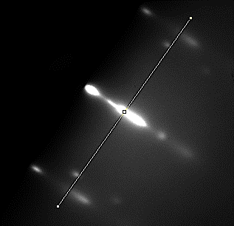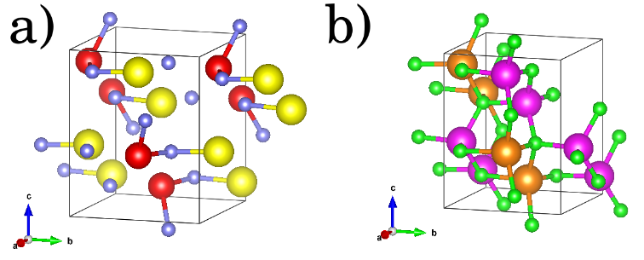

Figure 1. Part a) is the ZnSnN2 unit cell. The yellow elements represent tin (Sn), the red elements represent zinc (Zn), and the blue elements represent nitrogen (N). Part b) is the unit cell for LiGaO2 (LGO). The pink elements represent gallium (Ga), the orange elements represent lithium (Li), and the green elements represent oxygen. Both are these unit cells are based off space group Pn21a.

The films we have recently grown are ZnSnN2 and ZnGeN2 on substrates YSZ and LGO. Figure 1 shows a unit cell of ZnSnN2 and the unit cell of LGO. These were built using VESTA. Figure 2 then displays how it looks when ZnSnN2 is deposited on (001) of the LGO substrate. This modelling technique can be used to better understand and visualize how films are deposited on substrates.

Figure 3. This figure shows the RHEED image taken during the beginning stages of growth of ZnGeN2 of film WPI-110. The yellow line shown across the image is used to calculate the lattice constant. This line should be drawn perpendicular to the RHEED streaks. To draw the line a program called ImageJ is used.

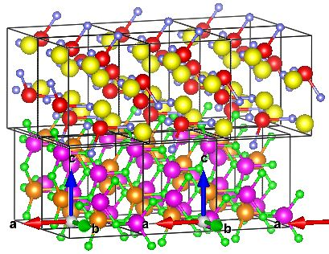*B. Polycrystalline Growth Results of ZnGeN2*

Figure 2. This figure shows the ZnSnN2 film on the LGO substrate. The film is on the (001) surface of LGO.

The parameters that are controlled during film growth include the substrate temperature, the metal fluxes, and the nitrogen flux. For this growth of ZnGeN2, the substrate temperature was set to 390oC. Because Zn has a high rate of desorption at these extreme temperatures, there will be a high Zn to Ge ratio used. For this growth, the temperature of Zn was set to 325oC and the Zn:Ge ratio was 18:1. Lastly, the RF power for the nitrogen plasma source can be controlled. To strike the plasma and obtain high brightness mode, we had to take the RF power up to over 200 watts. However, after obtaining the high brightness mode, we slowly decreased the RF power and maintained it at 150 watts.

Once all the parameters are set, growth can begin and RHEED images can be taken. Figure 3 shows the RHEED image taken during the beginning of growth of ZnGeN2. Using a program called ImageJ, the lattice constants of the film can be calculated. This is done by drawing a line perpendicular to the RHEED streaks as shown in Figure 3. From there, the corresponding intensity 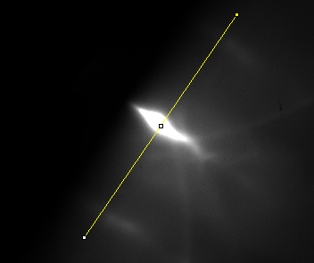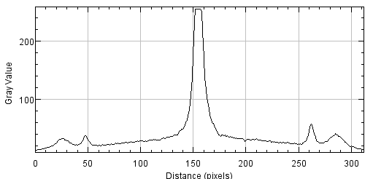profile across the RHEED pattern will be shown in a separate window. The corresponding intensity profile for Figure 3 is shown in Figure 4.

Figure 4. This is the corresponding intensity profile of the RHEED image shown in Figure 3. This is displayed using ImageJ after the yellow line is drawn perpendicular to the RHEED streaks.

Figure 5. This figure shows how we would draw a line perpendicular to the RHEED streaks of the substrate LGO. This will then lead to the graph shown in Figure 6.

This intensity profile is then used to calculate the lattice constant. The following equation is used when calculating the in-plane lattice constant:

Where Dparallel is the in-plane lattice constant, L is the length between the RHEED screen and where the RHEED screen is hitting the samples, 0 is the wavelength of the electron beam, and t is the pixel spacing between the streaks. Multiplying by t on either side:

Since L\*0 will always be constant, the equation can then be manipulated to be:

Where Dparallel,film is the in-plane lattice constant of the film, Dparallel,sub is the in-plane lattice constant of the substrate, tsub is the pixel spacing between the streaks of the substrate, and tfilm is the pixel spacing between the streaks of the film. The in-plane lattice constant of the substrate will be known. The pixel spacing of the substrate can be calculated before growth by evaluating the intensity profile of the RHEED image of the substrate. This is done by measuring the space in between the streaks.

For example, Figure 5 is the RHEED image of the substrate LiGaO2 (LGO) 010 before film WPI-110 was grown on it. To find tsub, draw the yellow line using ImageJ perpendicular the RHEED streaks. After the line is drawn, the intensity profile of the RHEED can be seen by clicking on Analyze > Plot Profile. After that, the intensity profile for the substrate will be displayed as shown in Figure 6. This graph can be used to calculate the pixel spacing of the substrate. This is done by taking the value for the distance in pixels at the farthest left most peak and subtracting it from the farthest right most peak and then dividing that value by the number of spaces between the peaks. For example, in Figure 6, to calculate tsub the following equation and values are used:

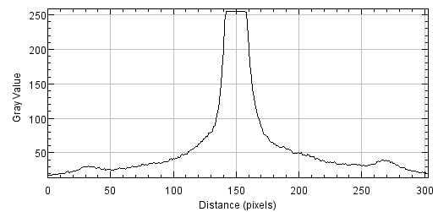Figure 6. This graph shows the intensity profile for the substrate LGO that the film WPI-110 was grown on. To find the pixel spacing find the distance between the two outermost peaks and then divide that value by the number spaces in between the peaks. As shown in this graph, the right most peak is about 258 and the left most peak is about 32. The value 32 will then be subtracted from 258 and divided by two because two is the number of spaces in between the peaks. Although these peaks are small, they can still be used to calculate the pixel spacing, tsub.

E:\Semiconductors\wpi111\ACQ00794.TIF

Figure 7. This figure shows that as we continued to grow the ZnGeN2 film on the LGO substrate, the film went polycrystalline. This is clearly shown in this RHEED image because of the rings circling the beam.

As for Dparallel,sub this value is a constant depending on the substrate used. Also, depending on the lattice structure, there could be one or two in-plane lattice constants for the substrate. Lattice structures such as zincblende, diamond, and other cubic structures, will only have one in-plane lattice constants. The wurtzite lattice structure could have one or two lattice constants depending on the plane that the film is being grown on. The orthorhombic lattice structure will always have two in-plane lattice constants. Because the substrate LGO is orthorhombic, there will be two in plane lattice constants. The two values for Dparallel,sub will be 5.406Å and 5.012Å.

We can calculate the tfilm by using the same method described for calculating tsub. The intensity profile for the film ZnGeN2 is shown in Figure 4. Since this intensity profile looks as though it is still displaying the streaks from the substrate, these peaks will be disregarded. Therefore, tfilm will be calculated using the following equation and values below:

Finally, the two in-plane lattice constants of the film, Dparallel,film can be calculated using the following equations and values:

These will be the two in-plane lattice constants of ZnGeN2.

As shown in Figure 7, as the growth of the film continues, we begin to see the film go polycrystalline. Further investigation is needed to determine why the films continue to turn polycrystalline. However, the faint RHEED streaks can still be analyzed to find the lattice constant.

*C. Polycrystalline Growth Results of ZnSnN2*

Most of the same steps were used for the growth of ZnSnN2. Our plan for this growth was to grow under the same conditions that we have used to grow a successful single crystal of ZnSnN2. If the growth was successful, we would then pause growth and then continue to grow ZnGeN2 on top of this 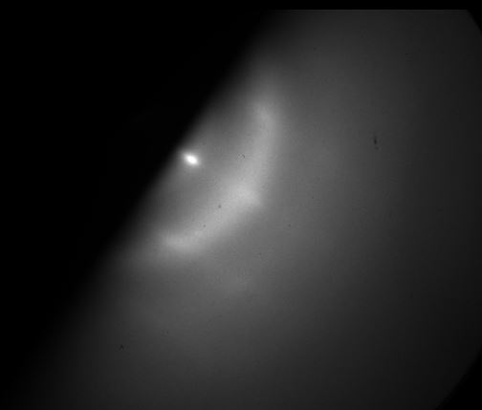film. We were hoping that since ZnSnN2 has less of a lattice mismatch than ZnGeN2 with YSZ (111), the substrate that we were using for this growth, that it would be easier to grow a single crystal of ZnGeN2 on top of ZnSnN2.

Figure 8. This figure shows the RHEED image taken during the beginning stages of growth of ZnSnN2. The RHEED streaks show signs of a polycrystalline film. This is clearly shown in this RHEED image because of the rings circling the beam.

Figure 9. This figure shows that a we continued to grow the ZnSnN2 film on the YSZ(111) substrate, the film went polycrystalline.

For this growth, the substrate, YSZ (111), temperature was set to 420oC. Because Zn has a high rate of desorption at these extreme temperatures, there will be a high Zn to Sn ratio used. For this growth, the temperature of Zn was set to 325oC, the temperature for Sn was set to 1025OC, and the growth manipulator (GM) temperature was set to 420oC. Lastly, the RF power for the nitrogen plasma source can be controlled. Once again, after obtaining the high brightness mode, we maintained the RF power at 150 watts.

Desorption of zinc has been mentioned as a problem while growing these films because of the high temperature they are required to be at. One of the ways that this is avoided is by adding a metal adlayer. This metal adlayer can be tin. It is important to have because it will make the pathway of desorption smaller. When observing the RHEED streaks of a film that has a metal adlayer, they are dimmer than films without. Additionally, you want a higher metal flux (such as Zn or Sn) than nitrogen flux because an excess of nitrogen can cause bumps in the RHEED streaks.

Once all the parameters are set, growth can begin and RHEED images can be taken. Figure 8 shows the RHEED image and the corresponding intensity profile across the RHEED pattern taken during the beginning of growth of ZnGeN2. However, as shown in Figure 9, as the growth of theE:\Semiconductors\wpi111\ACQ00792.TIF film continues, we begin to see the film go polycrystalline. We saw this film turn polycrystalline about 25 minutes in to growth. We had a slower growth rate than the previous films of about 25nm/hr. Further investigation is needed to determine why the films continue to turn polycrystalline.

*D. Possible Problems with the Plasma Source*

Because all the films grown recently have been turning polycrystalline after a few minutes into growth, we began to consider reasons as to why this would be happening. First, we considered that since we have been using a lot of Zn in all of growths, that maybe the Zn crucible was empty. Although, after further consideration, we believe that the true source of the problem is probably because of our plasma source.

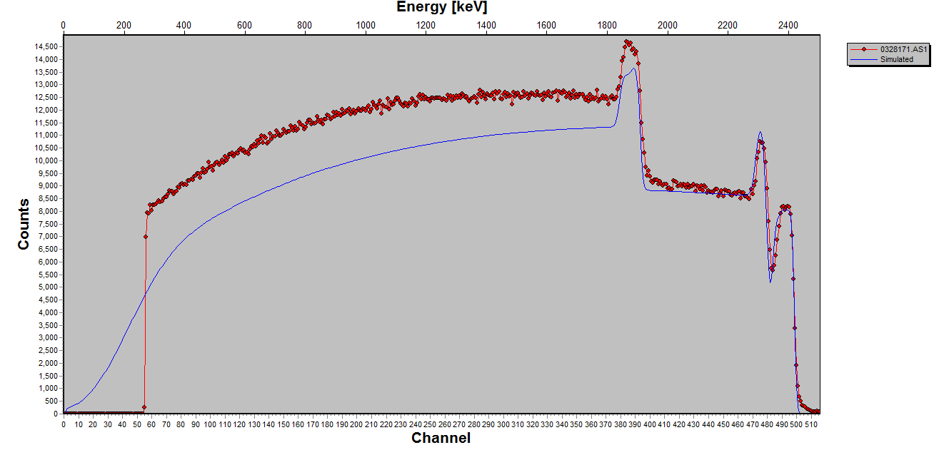

Boron location

Zinc location

Nitrogen location

Tin location

Figure 10. The red line in the figure above displays the RBS spectrum for the film labeled WPI-104. This film was suspected to have possible unintentional doping of boron. Each peak represents an element detected by RBS. There are peaks representing zinc, tin, and nitrogen since the film WPI-104 was ZnSnN2. However, there is no peak where boron would be. Because there is no visible sign of boron in this graph, this film is made of 1% or less of boron. The blue line is the data fitting line to the backscattering spectra. This graph was made using the program SIMNRA. This is a program used to simulate the backscattering spectra for ion beam analysis.

There have been several possibilities taken into consideration of why the plasma source is not working correctly. The plasma source may need to have the liner or another part replaced. Another possible option was that there could be unintentional doping of the films with boron. This has been known to happen in MBE because of decomposition of the pyrolytic boron nitride (PBN) cavity of the plasma source.

Because boron is so small, it can be hard to detect the presence of boron on our substrates. To try to determine if boron was indeed present, Rutherford Backscattering Spectrometry (RBS) was used. RBS is a method used to determine the atomic mass of elements and the distribution of depth of these elements. This information can be used to determine how thick and what elements the thin films are made of. It does this by scattering charged particles in a Coulomb field. This involves positively charged ions scattering because of the positive repulsion that comes from the element’s nucleus. Backscattering involves deflecting particles back in the direction that they came from to transfer energy to a stationary nuclear particle detector. Basically, there is an ion beam being directed at the film and based off the energy loss the ion experiences when it encounters the substance, will tell us what that particular film is made of. The C:\Users\york__000\AppData\Local\Microsoft\Windows\INetCacheContent.Word\ACQ02004.tifamount of energy loss will change between different elements because of the different masses each element has. With this surface analysis method, we can observe the chemical composition of our films to see if there is any boron contamination.

RBS was performed on the film WPI-104, which was one of the films that was suspected to have unintentional boron contamination. After performing RBS, the graph in Figure 10 was displayed. The three peaks expected, zinc, tin, and nitrogen, was clearly shown since the film grown was ZnSnN2; however, there was no boron peak. This means that there was no more than 1% of boron in this film. Anything above 1% is expected to give us a slight peak in the expected boron location. This gives us reason to believe that there is not unintentional doping of the films with boron.

C:\Users\york__000\AppData\Local\Microsoft\Windows\INetCacheContent.Word\ACQ01490.tif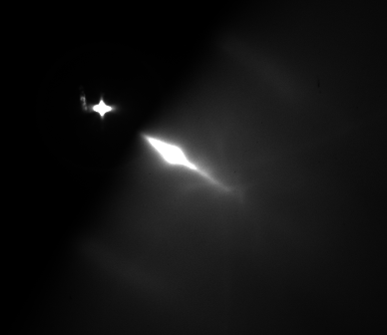The RHEED streaks for the substrate used to grow the film for WPI-104 is shown in Figure 11. ZnSnN2 was grown on substrate YSZ (111). For this growth, we planned on growing the first of a wurtzite series of films. Our growth conditions were going to be similar to WPI-99, but with slightly lower growth manipulator temperature of 370oC, slightly higher Sn temperature of 1120oC, and slightly lower N2 Flux power of 225W in an attempt to improve the growth quality.

Figure 12. This figure shows the RHEED streaks of the film ZnSnN2 when it was about 5 minutes into the growth process. It can be seen from this picture that there are slight rings beginning to form that are circling the beam. This is a clear sign that the film is beginning to be polycrystalline. There were slight adjustments made to try to stop this outcome.

Figure 13. This figure shows the RHEED streaks of the film ZnSnN2near the end of the growth process. This image clearly displays this film as polycrystalline.

Figure 11. This figure shows the RHEED streaks for the substrate YSZ (111). This substrate was used to grow ZnSnN2 on top of it.

When we were 5 minutes into the growth process of the film, we noticed that the film was beginning to go polycrystalline as shown in Figure 12. In an attempt to keep the film from continuing to go polycrystalline we paused growth, increased the Zn temperature from 325oC to 335oC, increased the growth manipulator temperature to 380oC, and then restarted growth. Even with these changes, the film continued to go polycrystalline as shown in Figure 13.

The program used to graph the RBS spectrums was SIMNRA. This is a program used to simulate the backscattering spectra for ion beam analysis shown in Figures 10 and 14. The red line in 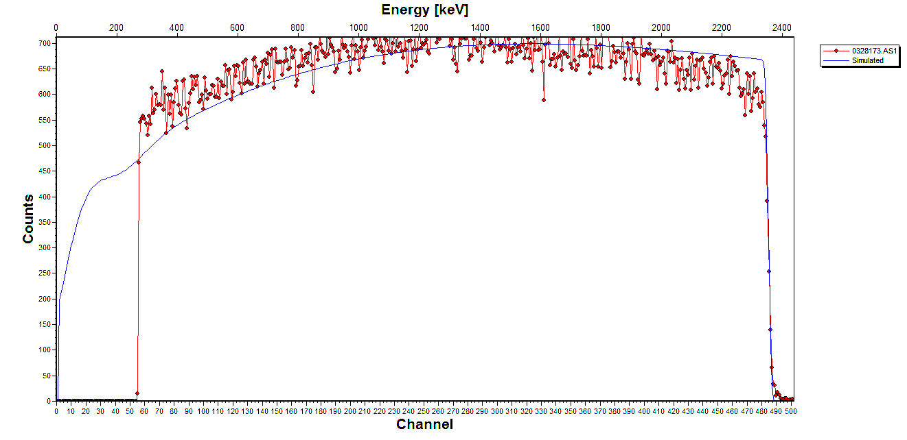the figures display the RBS spectrum for the elements examined. The blue line is the data fitting line to the backscattering spectra. This line is used to calibrate the data taken on the film we examined in Figure 10 because the samples were stuck onto copper tape.

Figure 14. The red line in the figure above displays the RBS spectrum for copper. This was measured because the samples were stuck on copper tape. The blue line is the data fitting line to the backscattering spectra. We use this to calibrate the data taken on the film in Figure 10. We can take the energy per channel we get from fitting the copper spectrum and use it when we try to fit to the sample when the exact composition is not known. By fitting the line, we can figure out both the thickness and the percentage of each element in the sample.

To make this line fit the experimental data, first setup the experiment. The incident ion is hydrogen, the energy is 2500 keV, the incident angle is 00, the exit angle is 300, the scattering angle is 1500, the energy per channel is 4.8546 keV/ch, the particles\*sr is 1.389E+11, and the detector resolution is 15 keV. Next, the target is setup by adding layers. The copper in Figure 14 will be the only element with a thickness of 100000E+15 atoms/cm2. The RBS spectrum in Figure 10 will have 2 layers. The first layer will represent the YSZ substrate the film was grown on. This will have 3 elements with a thickness of about 10200000E+15 atoms/cm2. The concentration for yttria will be 0.003228, for zirconia will be 0.397772, and for oxygen will be 0.599. The next layer will represent the film grown, ZnSnN2. This will have 3 elements with a thickness of about 5400E+15 atoms/cm2. Zinc and tin will have a concentration of 0.25 whereas nitrogen will have a concentration of 0.5. The total concentration of every layer must equal 1. The last step is to fit the spectrum which can be found under the calculate tab. Fit the energy calibration by checking that box and then click on fit. The blue line should then appear in relatively the same shape as the redlines are. Adjustments to the parameters can be made to better fit the line to the experimental data.

The fitted line in Figure 10 is slightly below the experimental line. This could be because we are at an angle and energy where the recorded scattering cross sections for oxygen are not as accurate as they could be. However, the fitted line is close. We can take the energy per channel we get from fitting the spectrum and use it when we try to fit to the sample when the exact composition of this sample is not known. By fitting the line, we can figure out both the thickness and the percentage of each element used in the sample.

Figure 16 This is the integrated intensity of the atomic species while varying radiofrequency (RF) power. From this graph, we can see that around 275W there is a spike in the intensity. The outlier point at 250W is suspected to be from a significant change in the nitrogen flow rate.

Figure 15. This is the integrated intensity of excited molecular species while varying radiofrequency (RF) power. This data was taken to be able to compare to the data in Figure 10. From this graph, we can see that around 275W there is a spike in the intensity. The outlier point at 250W is suspected to be from a significant change in the nitrogen flow rate.

*E. Characterizing the Atomic and Molecular Nitrogen*

We wanted to be able to characterize the atomic nitrogen and metastable excited molecules of nitrogen to be able to compare to the results of another paper. We did this because we wanted to be able to determine if there was a difference between the way our plasma source was acting compared to the way a different plasma source written about in a paper was acting.

Figure 17. This is the integrated intensity of excited molecular species while varying radiofrequency (RF) power. This data was taken from a paper [9]. When comparing this graph to the graph in Figure 8, the two graphs are not very similar.

As shown by the graphs in Figures 15, 16, and 17 there are two significant difference between the results of the two plasma sources. One difference being that in the figures that represent our RF power source (Figure 15 and 16) both the atomic and molecular have a spike in the data points around 275W. Figure 17 displays a rather linear trend. The second major difference being that with the data taken from our plasma source, there was an outlier point at 250W. This is suspected to be from a significant change in the nitrogen flow rate.

The trend for the integrated intensity of our molecular nitrogen is not the same as the integrated intensity for the molecular nitrogen taken from the paper. This is because where there is a jump in the data points, there was a different flow rate in that power range.

IV. ADDITIONAL INFORMATION AND EQUATIONS

*A. Lattice Mismatch*

Lattice mismatch happens because the lattice structure and constants do not match up between the film and the substrate. This can make it challenging to grow a film without having segregation or other defects. However, molecular beam epitaxy makes it easier to grow highly mismatched alloys because of its ability to circumvent the thermodynamic limits.

To calculate the lattice mismatch between the substrate and the film growing on top of it, the following equation is used:

Where f is the lattice mismatch, Dfilm is the lattice constant of the film and Dsub is the lattice constant for the substrate.

In Table 1, the lattice mismatch was calculated between the orthorhombic zinc tin nitride (ZSN) and the substrates we commonly use. In Table 2, the lattice mismatch was calculated between the wurtzite ZSN and the same substrates used in Table 1. Each direction (a, b, and c) was calculated. The calculation for the lattice mismatch between the orthorhombic ZSN and the substrate ZGN along the a direction.

Where the lattice constant for orthorhombic ZSN in the a direction is 6.812Å and the lattice constant for the wurtzite ZGN in the a direction is 3.167Å.

Table 1 This displays the lattice mismatch between orthorhombic ZSN and the various substrates we commonly use in our research.

|  |  |  |  |
| --- | --- | --- | --- |
| Substrate | Lattice structure | Direction | Lattice mismatch % |
| ZGN | wurtzite | a | 115.1 |
| ZGN | wurtzite | b | 86.7 |
| ZGN | wurtzite | c | 6.7 |
| YSZ | cubic | a | 33.0 |
| YSZ | cubic | b | 15.5 |
| YSZ | cubic | c | 8.2 |
| LGO | orthorhombic | a | 26.0 |
| LGO | orthorhombic | b | 18.0 |
| LGO | orthorhombic | c | 13.1 |
| GaN | zincblende | a | 50.7 |
| GaN | zincblende | b | 30.8 |
| GaN | zincblende | c | 22.6 |
| GaN | wurtzite | a | 113.6 |
| GaN | wurtzite | b | 85.5 |
| GaN | wurtzite | c | 6.9 |
| Ge | diamond | a | 20.4 |
| Ge | diamond | b | 4.5 |
| Ge | diamond | c | 2.1 |

Table 2 This displays the lattice mismatch between wurtzite ZSN and the various substrates we commonly use in our research.

|  |  |  |  |
| --- | --- | --- | --- |
| Substrate | Lattice structure | Direction | Lattice mismatch % |
| ZGN | wurtzite | a, b | 6.6 |
| ZGN | wurtzite | c | 6.5 |
| YSZ | cubic | a, b | 34.1 |
| YSZ | cubic | c | 8.0 |
| LGO | orthorhombic | a | 37.6 |
| LGO | orthorhombic | b | 32.7 |
| LGO | orthorhombic | c | 13.3 |
| GaN | zincblende | a, b | 25.3 |
| GaN | zincblende | c | 25.3 |
| GaN | wurtzite | a, b | 5.8 |
| GaN | wurtzite | c | 6.7 |
| Ge | diamond | a, b | 40.3 |
| Ge | diamond | c | 2.2 |

*B. Effusion and the Knudsen Equation*

The following equation is the Knudsen equation. This equation describes the effusion of a gas from a containing cylinder at low background pressure. It describes how a gas flows through a long cylinder in free molecular flow.

Where q is the volume flow rate, ΔP is the pressure drop over the length of the tube, ρ1 is the ratio of the density to pressure, d is the diameter of the tube, and l is the length of the tube.

To find the pressure drop over the length of the tube, the vapor pressure equation can be used:

Where A, B, C, and D are all constants depending on which element is being examined and if the element is either in the solid or liquid state of matter, T is the temperature in Kelvin, and P is pressure in atm.

If we were to solve for magnesium solid, we can find the constants in a look up table online. Plugging them into the equation will get us:

You can then use this number as the pressure in the Knudsen equation.

A Knudsen cell or an effusion cell is a thermal effusion evaporator. They are normally used in molecular beam epitaxy because of how easy it is to regulate the temperature of the evaporating materials while they are inside the low-pressure effusion cell. The Knudsen cell measures the volume flow rate and the vapor pressure by measuring the vapor that has effused through the tube and determining the amount of mass that has been lost. It does this by measuring the collisions in this tube and calculating the mean free path. The mean free path is the average distance between collisions in a cylinder. It is calculated using the following equation:

Where R is the universal gas constant 8.3145 J/molK, T is the temperature, d is the diameter of the molecule. P is the pressure, and NA is Avogadro’s number 6.022\*1023/mol.

The Knudsen equation is based on the assumption that the rate at which the molecules are flowing through this tube is equal to the rate where the molecules would hit that small area of the wall if that tube was not open. For this assumption to hold true, the radius of the hole must be significantly smaller than the mean free path calculated. Because of the vacuum in place, there will be a low vapor pressure creating a long enough mean free path to allow for the Knudsen equation to be accurate.

*C. Space Groups*

Space groups are a way to label and describe the 3D crystal structure of certain substances. When you know the space group, you then know what the unit cell would look like and the symmetry that the crystal has. There is a total of 230 space groups made up of 7 different crystal systems. These crystal systems are called triclinic, monoclinic, orthorhombic, tetragonal, trigonal, hexagonal, and cubic. They are further labelled after the crystallographic point-group symmetry as well as their lattice type.

One of the films mentioned earlier in this paper was ZnGeN2 that was grown on the substrate LGO. This substrate is part of space group 33 with Pn21a symmetry. With this information, you can figure out that the crystal system is orthorhombic, what the unit cell looks like, what the point group is, what symmetry elements are present, and other defining parameters. It is also important to note that the ordering of the numbers and letters are important in determining the characteristics of the unit cell. For example, Pn21a and Pna21 describe two different types of space groups and unit cells, but are both under the space group 33. Pn21a and Pna21 have different symmetry operators, axes, and origins. To convert between the two, Pna21 can be rotated around the x-axis 900. This will keep the a direction the same, but the coordinates for directions b and c will switch.

V. CONCLUSION

Several of films of ZnSnN2 and ZnGeN2 have been grown on substrates using plasma assisted molecular beam epitaxy (PAMBE). These films were chosen because they can provide a more environmentally friendly and cost saving alternative. Growth conditions can be changed such as substrate temperatures and the ratios of the metal fluxes to tune the band gap. There have been several attempts made to produce a high quality, single crystal film. Although only polycrystalline films have been produced this semester, there is still much to learn from these films. The films have been examined using RBS to determine the atomic mass of elements and the distribution of depth of these elements. This was done to determine if unwanted boron doping was affecting our films, however, it is suspected that there is a different problem with our plasma source.

The integrated intensity graphs of excited molecular species while varying radiofrequency (RF) power were compared to the excited molecular species in a paper. This was done to see if there were any variations to give us clues what was wrong with our plasma source. Although there were slight variations, this was just because of the different flow rates taken at that time.

To determine the root cause of why all the films have been going polycrystalline, we will need to bring the chamber up to air and check the crucibles, the plasma source, and other parts of the machine. Additionally, we are about to receive a new magnesium crucible. Once the machine is running again and back to the correct vacuum pressure, we will begin to grow films with the magnesium and the other elements.

VI. REFERENCES

[1] ioffe, “Ge - Germanium.” [Online]. Available: http://www.ioffe.ru/SVA/NSM/Semicond/Ge/basic.html.

[2] ioffe, “GaN - Gallium Nitride.” [Online]. Available: http://www.ioffe.ru/SVA/NSM/Semicond/GaN/basic.html.

[3] CrysTec, “Y:ZrO2 - YSZ for Research and Development.” [Online]. Available: http://www.crystec.de/daten/ysz.pdf.

[4] MatWeb, “MarkeTech Lithium Gallium Oxide (LiGaO2) Single Crystal Substrate.” [Online]. Available: http://www.matweb.com/search/datasheet.aspx?matguid=0e4f481494fa482ca60498956f57596b&ckck=1.

[5] O. Madelung, *Semiconductors: Data Handbook; Ix - VIy compounds*, 3rd ed. Springer, 2004.

[6] F. Rinaldi, “Basics of Molecular Beam Epitaxy,” *Annu. Rep.*, p. 31, 2002.

[7] J. K. Cockcroft, “Introduction to Space Groups,” *Birkbeck College, University of London.*, 1995. [Online]. Available: http://pd.chem.ucl.ac.uk/pdnn/symm3/sgintro.htm.

[8] Ucl, “Space Group Diagrams and Tables,” *University College London website*, 1997. [Online]. Available: http://img.chem.ucl.ac.uk/sgp/large/sgp.htm.

[9] N. Feldberg, B. Keen, J. D. Aldous, D. O. Scanlon, P. A. Stampe, and R. J. Kennedy, “ZnSnN 2 : A New Earth-Abundant Element Semiconductor for Solar Cells,” *Photovolt. Spec. Conf. (PVSC), 2012 38th IEEE*, pp. 2524–2527, 2011.

[10] N. Senabulya *et al.*, “Stabilization of orthorhombic phase in single-crystal ZnSnN2 films,” *AIP Adv.*, vol. 6, no. 7, 2016.

[11] T. D. Veal *et al.*, “Band Gap Dependence on Cation Disorder in ZnSnN2 Solar Absorber,” *Adv. Energy Mater.*, vol. 5, no. 24, pp. 1–5, 2015.

[12] N. Materer, R. S. Goodman, and S. R. Leone, “Comparison of electron cyclotron resonance and radio-frequency inductively coupled plasmas of Ar and N-2: Neutral kinetic energies and source gas cracking,” *J. Appl. Phys.*, vol. 83, no. 4, pp. 1917–1923, 1998.

[13] R. A. Makin *et al.*, “Growth of ordered and disordered ZnSnN2,” *J. Vac. Sci. Technol. B, Nanotechnol. Microelectron. Mater. Process. Meas. Phenom.*, vol. 35, no. 2, p. 02B116, 2017.

[14] N. Feldberg *et al.*, “Growth, disorder, and physical properties of ZnSnN2,” *Appl. Phys. Lett.*, vol. 103, no. 4, 2013.

[15] V. Vonk, N. Khorshidi, A. Stierle, and H. Dosch, “Atomic structure and composition of the yttria-stabilized zirconia (111) surface,” *Surf. Sci.*, vol. 612, pp. 69–76, 2013.

[16] S. Prucnal and F. Liu, “Highly Mismatched Alloys,” 2016. [Online]. Available: https://www.hzdr.de/db/Cms?pOid=37792&pNid=0. [Accessed: 02-Apr-2017].

[17] A. G. Aberle, “Thin-film solar cells,” *Thin Solid Films*, vol. 517, no. 17, pp. 4706–4710, 2009.

[18] H. S. Ullal, “Polycrystalline Thin-Film Solar Cell Technologies: Preprint,” no. December 2008, 2009.

[19] S. V. Novikov and C. T. Foxon, “Unintentional boron incorporation in AlGaN layers grown by plasma-assisted MBE using highly efficient nitrogen RF plasma-sources,” *J. Cryst. Growth*, no. xxxx, pp. 1–5, 2017.

[20] J. Perriere, “Rutherford backscattering spectrometry,” *Vacuum*, vol. 37, no. 5–6, pp. 429–432, 1987.

[21] E. Iliopoulos, A. Adikimenakis, E. Dimakis, K. Tsagaraki, G. Konstantinidis, and A. Georgakilas, “Active nitrogen species dependence on radiofrequency plasma source operating parameters and their role in GaN growth,” *J. Cryst. Growth*, vol. 278, no. 1–4, pp. 426–430, 2005.

[22] A. Ptak, K. Ziemer, M. Millecchia, C. Stinespring, and T. Myers, “Influence of Active Nitrogen Species on the Nitridation Rate of Sapphire,” *Appl. Phys. Lett.*, vol. 537, pp. 1–6, 2017.

[23] M. J. Madou, *Molecular Beam Epitaxy*. Berlin: Springer, 2001.

[24] M. Herman and H. Sitter, *Molecular Beam Epitaxy: Fundamentals and Current Status*, 2nd ed. Berlin: Springer Science & Business Media, 1989.

[25] J. Gyulai, *Rutherford Backscattering Spectrometry*. Budapest: Central Research Institute for Physics, 1980.

[26] L. Brillson, *Surfaces and Interfaces of Electronic Materials*. Wiley, 2010.

[27] F. Ernst, “Rutherford Backscattering Spectrometry,” 2005.

[28] Shoemaker, Nibler, and Garland, “Vapor Pressure of a Solid by Knudsen Effusion,” *Atkins 7th Ed.*, pp. 117–126, 2009.

[29] Department of Physics and Astronomy Georgia State University, “Mean Free Path,” *Hyperphysics*. [Online]. Available: http://hyperphysics.phy-astr.gsu.edu/hbase/Kinetic/menfre.html.

[30] M. Mayer, “‘SIMNRA User’s Guide’, Tech. Report IPP, 9/113,” *Rep. IPP*, p. 9/113, 1997.

[31] M. Mayer, “‘SIMNRA User’s Guide’, Tech. Report IPP, 9/113,” *Rep. IPP*, p. 9/113, 1997.